 | YEAR 12 MATHEMATICS SPECIALIST  SEMESTER TWO 2016  TEST 4: Motion and Differential Equations

Name: _______________________

Monday 12th September Time: 50 minutes Mark /45

Section 1 – Calculator free 20 marks

[5 marks – 4 and 1]
The noise level, in decibels, of the Year 9 class next door is increasing at a rate proportional to the square root of itself, i.e. . The noise level started at 64dB and rose to 100dB in 20 minutes.
- Write and solve an appropriate differential equation to model this situation

- How long from the start will it take to exceed the pain threshold by reaching 144 dB?

[6 marks – 1 each]
A particle is moving in simple harmonic motion with its acceleration at time t given by , for k a constant.

- Express each of these quantities in terms of k:

the period of motion

the frequency of motion

the amplitude of the motion

the displacement
- If the maximum speed of the particle is 6 units, evaluate:

k

the amplitude

[3 marks]
An object, with displacement x and velocity v, moves so that m/s.

What is the acceleration of this object it is 2 metres from the origin?

[6 marks – 1, 2 and 3]
  - Enter the values of in this table.
x | y
1 | 2
 | 3
3 | 0

  - 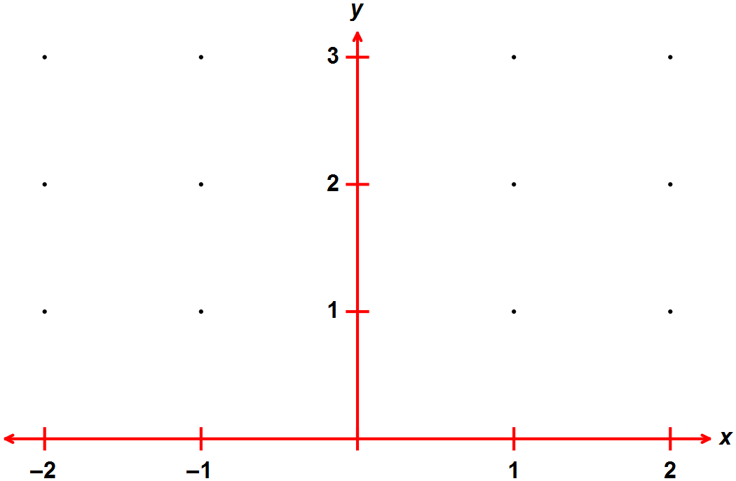Use these values and others from the 20 integer points marked to draw the slope field for the differential equation .

  - Solve the differential equation if y = 2 when x = 0.

Section 2 – Calculator assumed 25 marks

Name: _______________________

[3 marks – 2 and 1]

- Continuing with , complete the table to find the coordinates of the next two points, starting from (2, 1), when the incremental formula (Euler’s method) is applied.

x | y
2 | 1 | 0.1
 |  | - | -

- What can be said about the initial (boundary) condition if and the graph produced using Euler’s method is a horizontal line?

[3 marks – 2 and 1]

The velocity of particle P₁ is given by while that of P₂ is given by .
Both particles are moving along the same straight line and are initially at the origin O.

- When is the velocity of the two particles the same?

- What distance is covered by P₂ up to and when the velocities are equal?

[12 marks – 2, 6, 2, 1 and 1]
An advertising executive commissioned a mathematical analysis of the effectiveness of a particular television campaign.

The rate of increase in the percentage of the market (P) aware of the product was modelled by , at t weeks

- This equation has the rate of increase proportional to two basic quantities. What are they?

- Use appropriate calculus techniques to derive .

If 20% of the market was initially aware of the product, determine:
- the proportion aware after 2 weeks of advertising

- how long before 75% of the market is aware

- the maximum or limiting value of market awareness

PTO for question 8

[7 marks – 2, 1, 1, 1 and 2]
A steam-driven piston has a displacement, x, given by
- Show that the piston is in simple harmonic motion.

Determine each of:
- the amplitude.

- the first two values of t, , when the piston is in its central (mean) position

- the initial direction of travel

- the velocity when

